Monday February 15th 2016
Session 1- 9:00AM-12:00PM
Session 2- 12:00PM-4:00PM
All day- 9:00AM-4:00PM

Featuring baseball great - Dave Collins
Baseball Camp!
Dave Collins’

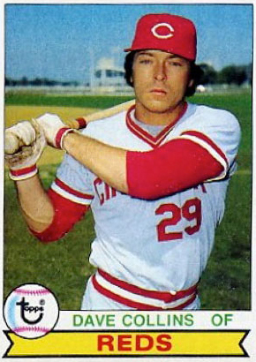
Limited to only 25 players!

sharpen your baseball skills with this one day camp with former Reds great Dave Collins!

Session 1- Pitching and Fielding

Session 2- Hitting

Cost per session is $40.00 or come to both for $70.00

($70.00 includes lunch & round table discussion with Dave Collins on the mental game of baseball)

To Register: Fill out form or log into your esoft account

Age __________ d.o.b. _____________

Team ______________________________________

Session (Circle one): 1 2 Day

Player Name _____________________________

Parent name _____________________________

Phone _____________________________________

Email _____________________________________

419 Licking Pike
Wilder, KY 41071
859-291-3000
NextLevelNKY@gmail.com
Administration:
Paid ________
Date Paid ____________
